STATISTICAL DATA
ANALYSIS DASHBOARD
Used Car Listings Dataset (CarDekho)
Dashboard Design and Data Interpretation Assignment
CSC213 — Data Mining and Exploration
Instructor: Dr. Samia Mohammed Mohammed Abd-Alhalem
GROUP MEMBERS
Mosab Ahmed Almoghazy — 42510895
Mariam Mahmoud Khalil — 42510361
Mohamed Gamal Suleiman — 42510937
Samira Ali Abdel Ghaffar — 42511156
Mohamed Abdelnaser Maghawry — 42510518
Mariam Ahmed Reda — 42510939
Malak Ahmed Al-Badawi — 42510709
Fatima Amin El-Metwally — 42510356
Prepared using Microsoft Excel

1. Executive Summary
This report documents a statistical analysis dashboard built in Microsoft Excel for a used car listing dataset collected from CarDekho, an Indian online automobile marketplace. The dataset contains 6,717 listings covering model years 1994 to 2020, with 12 attributes per record (five categorical and seven numeric). The dashboard combines four KPI cards, a scatter plot with a fitted linear trendline, a column chart of average price by fuel type, a doughnut chart of transmission types, a correlation heatmap, and a slicer that filters every visual by car name.
The analysis shows that the average listed price is 526,386 against a median of 420,000, which indicates a right-skewed price distribution driven by a small number of high-end listings (maximum 10,000,000). Maximum engine power is the variable most closely associated with price (r = 0.692), and the scatter trendline explains about 47.9% of the variation in horsepower (R² = 0.4793). Diesel cars hold the highest average price (647,996), and manual transmission accounts for 91.4% of all listings. These results are described and interpreted in the sections below.

2. Project Purpose and Objectives
The purpose of this project is to turn a raw used car listing dataset into an interactive dashboard that summarizes market characteristics and supports data-driven conclusions. The specific objectives are:
- Load the dataset into Microsoft Excel and verify its structure and data types.
- Examine the data for missing values, duplicate records, and implausible values.
- Compute descriptive statistics for the seven numeric variables.
- Build a dashboard with at least four visualizations, each with a clear title, axis labels, and legends.
- Add an interactive slicer so that every chart can be filtered by a single car model.
- Report the findings, including the statistical relationships observed between variables.

3. Dataset Description
The dataset contains 6,717 used car listings advertised on CarDekho. Each row describes one car: its model name, fuel type, seller type, transmission, ownership history, kilometers driven, listed price, manufacturing year, fuel efficiency, engine displacement, maximum power, and seating capacity. The listings cover 1,982 distinct car models from brands such as Maruti (2,089 listings), Hyundai (1,214), Mahindra (709), and Tata (633). Prices range from 29,999 to 10,000,000, and model years range from 1994 to 2020.

3.1 Dataset Variables
Variable | Type | Description
name | Text | Brand, model, and variant of the listed car
fuel | Categorical | Fuel type: Diesel, Petrol, CNG, or LPG
seller_type | Categorical | Seller: Individual, Dealer, or Trustmark Dealer
transmission | Categorical | Gearbox: Manual or Automatic
owner | Categorical | Ownership stage: First Owner to Test Drive Car
km_driven | Numeric | Total kilometers the car has been driven
selling_price | Numeric | Listed selling price of the car
year | Numeric | Manufacturing year of the car
mileage(km/ltr/kg) | Numeric | Fuel efficiency in kilometers per liter or kilogram
engine | Numeric | Engine displacement in cubic centimetres (cc)
max_power | Numeric | Maximum engine power in bhp
seats | Numeric | Number of seats

3.2 Dataset Information
Dataset filename: Project Data mining(1).xlsx (worksheet: Dataset"DM"1)
Source / download location: CarDekho used car listings, publicly released on Kaggle.
Number of rows in the loaded file: 6,717
Number of columns in the loaded file: 12 (5 categorical and 7 numeric)
Range covered: Model years 1994–2020; listed prices 29,999–10,000,000.
Data preparation performed: The sheet was loaded in Excel and checked for missing values and duplicates; descriptive statistics and a Pearson correlation matrix were computed for the numeric columns.

4. Data Preparation and Cleaning
Before building the dashboard, the dataset was inspected in Excel with the following checks:
- Missing values: all 12 columns were checked; no empty cells were found, so no imputation was required.
- Duplicate records: no duplicate rows were detected, so no rows were removed on this basis.
- Data types: the five descriptive columns (name, fuel, seller_type, transmission, owner) are text columns, and the remaining seven columns are numeric and usable directly in charts and pivot tables.
- Value ranges: km_driven ranges from 1 to 2,360,457, with 3 records above 500,000 km. selling_price ranges from 29,999 to 10,000,000, with 49 records above 3,000,000. mileage(km/ltr/kg) equals 0 in 15 records, which appears to be a recording error in the source data.
- Treatment: all records were kept so that the dashboard reflects the dataset as published. The extreme values were noted because they influence the mean and the standard deviation, especially for km_driven and selling_price.
- Final row count after preparation: 6,717 records, which is the count used in every dashboard visual.
Descriptive statistics were then generated for the seven numeric columns (mean, standard error, median, mode, standard deviation, variance, kurtosis, skewness, range, minimum, maximum, sum, and count), and a correlation matrix was computed to quantify the linear relationships between them.

5. Dashboard Design and Visualizations
The assignment requires at least four visualizations. The dashboard built for this project contains six interactive elements arranged on a single Excel sheet: four KPI cards at the top, a scatter plot, a column chart, a doughnut chart, a correlation heatmap, and a car-name slicer on the right that filters every visual at once.

5.1 KPI Cards — Summary Measures
Purpose: summarize the dataset in four numbers visible at a glance. The cards show: Average Price = 526,386; Maximum Price = 10,000,000; Total Vehicles = 6,717; Average Horsepower = 88. The gap between the average price (526,386) and the median price (420,000, from the descriptive statistics) shows that the average is pulled upward by a small group of expensive listings; the median is therefore the better measure of a typical car in this dataset.

5.2 Horsepower and Price — Scatter Plot with Trendline
Purpose: test whether more expensive cars tend to produce more power. The scatter plot places selling price on the horizontal axis and maximum power on the vertical axis for all 6,717 listings, with a linear trendline fitted through the points: y = 4E-05x + 65.684, where y is maximum power and x is price. The coefficient of determination is R² = 0.4793.
Interpretation: the relationship is positive — as price increases, horsepower tends to increase. The slope implies that each additional 25,000 in price corresponds to about 1 bhp of extra power on average (1 ÷ 0.00004 = 25,000). The R² value means that price alone accounts for about 47.9% of the variation in horsepower; the rest is influenced by factors not shown in this chart, such as brand, fuel type, and car age. This result is consistent with the correlation heatmap, where the Pearson correlation between selling price and maximum power is 0.692 (0.692² ≈ 0.479). The plot also shows that most listings cluster below 200 bhp and under 2,000,000 in price, with a few high-power luxury cars far to the right that stretch the horizontal scale.

5.3 Average Price by Fuel Type — Column Chart
Purpose: compare average prices across the four fuel types. The chart reports: Diesel = 647,996; Petrol = 384,051; CNG = 317,667; LPG = 210,886.
Interpretation: diesel cars are the most expensive group on average — about 69% higher than petrol and roughly three times the LPG average. This matches the structure of the dataset: diesel listings (3,658 of 6,717, or 54.5%) are concentrated in larger SUVs and sedans with bigger engines, while CNG and LPG cars (51 and 35 listings) are mostly small city cars. Because the CNG and LPG groups are very small, their averages are less stable than the diesel and petrol figures.

5.4 Transmission Distribution — Doughnut Chart
Purpose: show the split between manual and automatic transmissions. Manual accounts for 6,142 listings (91.4%) and automatic for 575 listings (8.6%).
Interpretation: the used car market in this dataset is overwhelmingly manual, which reflects a market where manual gearboxes dominate the economy segment. A further check in the data shows that automatic cars are not only rarer but also more expensive on average (about 1,322,916 versus 451,817 for manual cars), so the automatic segment is concentrated in the premium and newer parts of the market.

5.5 Correlation Heatmap — Numeric Variables
Purpose: measure the strength and direction of the linear relationships between the seven numeric variables. The heatmap displays the following Pearson correlation coefficients:
 | km_driven | selling_price | year | mileage | engine | max_power | seats
km_driven | 1
selling_price | −0.161 | 1
year | −0.388 | 0.427 | 1
mileage | −0.196 | −0.109 | 0.366 | 1
engine | 0.253 | 0.443 | −0.020 | −0.579 | 1
max_power | 0.042 | 0.692 | 0.160 | −0.379 | 0.684 | 1
seats | 0.208 | 0.159 | 0.025 | −0.459 | 0.659 | 0.259 | 1

Interpretation: three relationships stand out. First, maximum power and selling price correlate at 0.692 — the strongest positive relationship in the matrix and the basis of the scatter plot above. Second, engine size, power, and seats correlate strongly with one another (0.684 and 0.659), forming a block of variables that describe car size and performance. Third, engine size and fuel efficiency correlate at −0.579: bigger engines consume more fuel, as expected mechanically. Newer cars (higher year values) tend to have lower km_driven (−0.388) and higher prices (0.427). Km_driven, however, correlates only weakly with price (−0.161), which suggests that distance travelled by itself is a weak price signal once other factors are considered. Correlation measures association, not causation.

5.6 Interactive Slicer — Car Name
Purpose: make the dashboard explorable. The slicer on the right side of the dashboard lists all car names (for example, the Chevrolet Enjoy and Chevrolet Optra variants). Selecting one or more names filters the KPI cards, the scatter plot, the fuel chart, the transmission chart, and the heatmap together, so the user can inspect a single model or brand against the same measures.

6. Dashboard Interface Screenshots
The screenshots below show the dashboard as it appears in Excel, including the KPI cards, all charts, and the slicer in its default state.
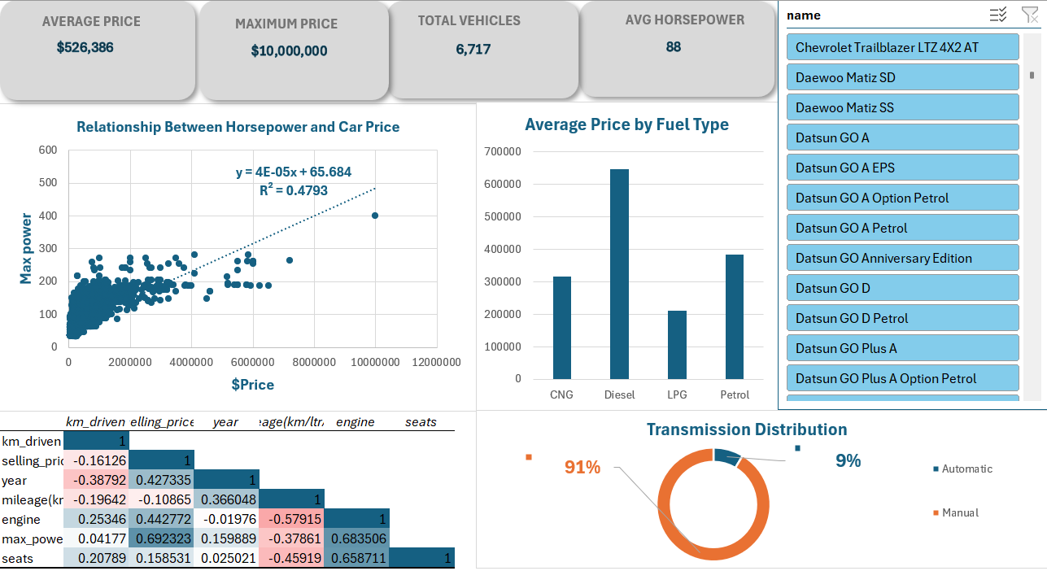

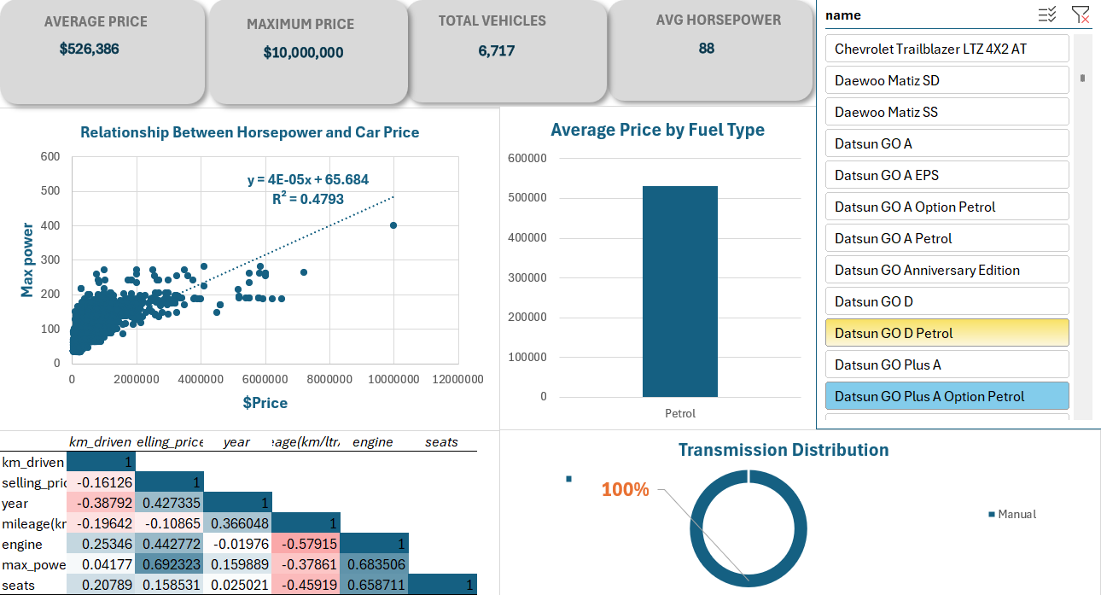

7. Dataset Evidence / Insert Dataset into This Word File
The image below previews the first rows of the dataset worksheet used for the analysis.
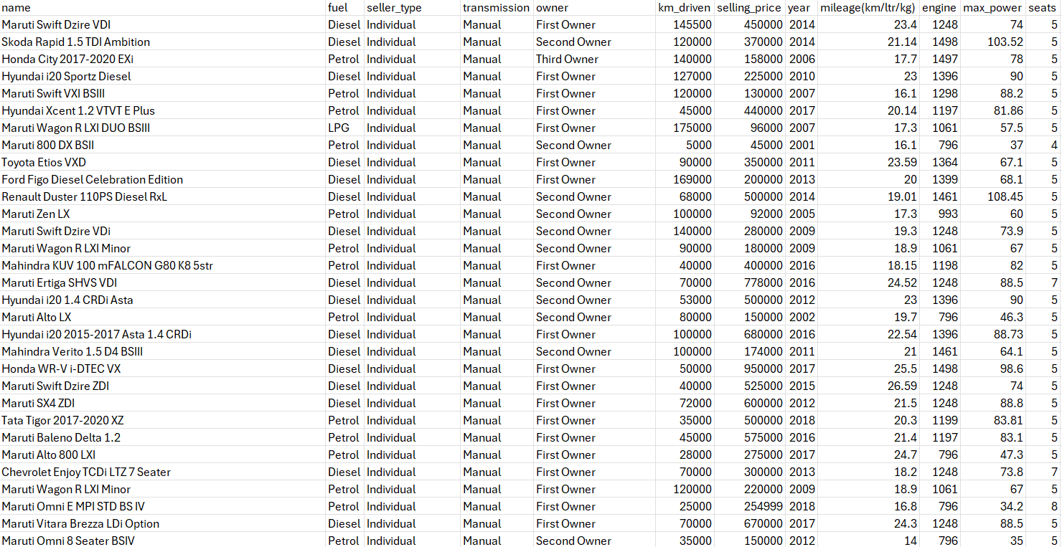

Original dataset file attached separately for submission: ☐ CSV ☒ Excel Filename: Project Data mining(1).xlsx

8. Main Findings and Insights
- Dataset size and completeness: 6,717 listings across 1,982 models, with no missing values and no duplicates; the final row count equals the loaded row count.
- Price distribution: the mean price is 526,386 against a median of 420,000, with a standard deviation of 523,550, skewness of 5.57, and kurtosis of 52.49. The distribution is strongly right-skewed: 49 listings are priced above 3,000,000, including one at 10,000,000, and these pull the mean upward. The median describes the typical listing better than the mean.
- Power as a price driver: max_power correlates with selling_price at 0.692, which corresponds to R² = 0.4793 in the scatter plot. It is the strongest single linear predictor among the numeric variables, yet it still explains less than half of the variation on its own.
- Fuel type: diesel cars average 647,996, compared with 384,051 for petrol, 317,667 for CNG, and 210,886 for LPG. Diesel makes up 54.5% of all listings and sits clearly above the other fuel types in price.
- Transmission: 91.4% of listings are manual. Automatics are rare (8.6%) but average 1,322,916, close to three times the manual average of 451,817, which places them in the premium segment of this market.
- Age and usage: year correlates positively with price (0.427) and negatively with km_driven (−0.388), so newer cars have been driven less and sell for more. The direct correlation between km_driven and price is weak (−0.161), so distance travelled alone is a poor price indicator.
- Efficiency trade-off: engine size correlates negatively with mileage (−0.579) and seats correlate negatively with mileage (−0.459), confirming that larger, multi-seat cars are less fuel-efficient.
- Data quality flags: 15 records report zero mileage and 3 records report more than 500,000 km. The km_driven variable has a skewness of 11.92, so its mean (73,398 km) should be interpreted cautiously.

9. Conclusions
The dashboard meets the assignment requirements: it presents a cleaned 6,717-record dataset through four KPI cards and five chart types, all connected to an interactive slicer, and every visual carries a title, labels, and a legend.
The analysis answers the main questions posed by the data. Used car prices in this market are right-skewed, so typical values are best described by the median (420,000) rather than the mean (526,386). Maximum power is the strongest single linear correlate of price (r = 0.692), but even the fitted trendline explains less than half the variation in horsepower (R² = 0.4793), which indicates that a complete price model would need additional predictors such as brand, fuel type, ownership stage, and age. Fuel type separates the market into clear price bands, with diesel at the top, and transmission is dominated by manual cars, while the smaller automatic segment sits in a higher price range.
The dashboard also has clear limitations. Correlation does not imply causation, the dataset covers only the Indian used car market, and it contains no variables for vehicle condition, accident history, or region, all of which influence real prices. Several variables (price, km_driven, and power) are heavily skewed, so a future version of this analysis could apply a logarithmic transformation to price and fit a multiple linear regression to quantify the joint effect of power, year, engine size, and fuel type. Within those limits, the dashboard provides a reliable, reproducible summary of the dataset and the relationships inside it.

